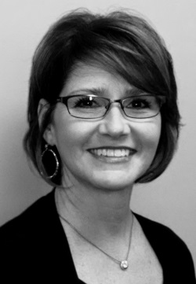
Paula J. Shaw has over twenty five years of experience in public administration with a diverse background in the motor vehicle and transportation industry with emphasis on regulatory, business excellence and project management. She currently holds the position of Executive Director of the Tennessee Motor Vehicle Commission. In her role as Executive Director, she is responsible for ensuring that Tennessee auto industry participants are abiding by all laws, rules and regulations that are intended to empower consumers while allowing all dealers to compete for business on a level playing field. The Commission licenses franchised and independent motor vehicle dealers, recreational vehicle dealers, manufactures, dismantler recyclers, auto auctions, distributors, salespersons and representatives.
Paula started her motor vehicle career as a field investigator for the Commission. Subsequent to her appointment as the Executive Director of the Motor Vehicle Commission she held several other transportation related positions throughout the State of Tennessee including former Director of the Titling and Registration Division and former Director of the Multimodal Transportation Division, with oversight over vehicle titling, registration, public transportation, rail, waterways and freight transportation.
Paula earned a Bachelor’s Degree in Business Management from Trevecca University, is a graduate of the University of Tennessee Executive Leadership Institute and has represented her state on numerous state, local and national boards including the American Association of State Transportation Officials and the American Association of Motor Vehicle Professionals. She is currently an active member of the Chamber of Commerce, serves on the Regional Transportation Authority in middle Tennessee and is an active member of the National Association of Motor Vehicle Boards serving a secretary. Paula has also served on the Board of Examiners for the Tennessee Baldrige Center for Performance Excellence and is a trained Examiner. She is a native Tennessean and has two grown children and three grandchildren.

