NATIONAL ASSOCIATION OF MOTOR VEHICLE
BOARDS AND COMMISSIONS

www.namvbc.org

Fall Conference Registration Form – September 27-30, 2023

Best Western Premier Park
22 S Carroll St, Madison, WI 53703
Phone: (608)285-8000
Please use this link to book your reservation under the NAMVBC conference rate.

https://www.bestwestern.com/en_US/book/hotel-rooms.50061.html?groupId=D21IH0P4

*PLEASE SUBMIT A SEPARATE REGISTRATION FORM FOR EACH PERSON ATTENDING THE WORKSHOP*
NAME:
NAME AS YOU WANT IT TO APPEAR ON BADGE, IF DIFFERENT:
TITLE:
COMPANY:
ADDRESS:
CITY, STATE, ZIP:
PHONE:
EMAIL:
Late Registration (September 5 – 22, 2023)
Attendee ☐$250
Guest ☐$125
Name of Guest_________________________
I plan to attend (for planning purposes):
☐Wednesday evening reception
☐Thursday evening event
☐Friday evening event

Regular Registration (cutoff September 4, 2023)
Attendee ☐$175
Guest ☐$75
Name of Guest _________________________
I plan to attend (for planning purposes):
☐Wednesday evening reception
☐Thursday evening event
☐Friday evening event

Paying by credit card or ACH payment?

Please return completed sponsorship form to monique.johnston@txdmv.gov and use the secure QR code payment link below:

☐ I will be paying through the secure link
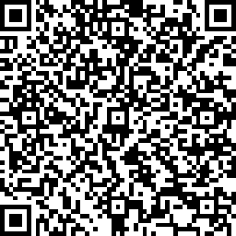
If you have questions about this invoice or issues with the QR code payment link, please contact Monique Johnston at: monique.johnston@txdmv.gov
(512) 560-4371

If paying by check, please make payable to NAMVBC and mail with registration form to:
Monique Johnston, MVD Division Director
Texas Department of Motor Vehicles
4000 Jackson Ave, Bldg 1
Austin, TX 78731

