NATIONAL ASSOCIATION OF MOTOR VEHICLE
BOARDS AND COMMISSIONS

www.namvbc.org

Fall Conference Sponsorship Form – September 27-30, 2023

Name of Organization: Click or tap here to enter text.
Contact Name for Sponsorship Questions: Click or tap here to enter text.
Contact Phone Number: Click or tap here to enter text.
Contact E-Mail: Click or tap here to enter text.
Sponsorship Level (check one):
☐ Diamond Level $10,000 and up **10 free registrations**
☐ Platinum Level $7,500 **5 free registrations**
☐ Gold Level $5,000 **2 free registrations**
☐ Silver Level $2,500
Amount of Sponsorship Donation: Click or tap here to enter text.
Preferred Event(s) to Sponsor: Click or tap here to enter text.
For Diamond, Platinum and Gold Level Sponsors – Names of Attendees who will be receiving free registrations: Click or tap here to enter text.
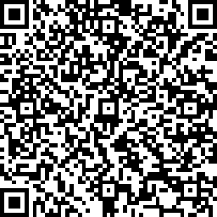
If you have questions about this invoice or issues with the QR code payment link, please contact Monique Johnston at: monique.johnston@txdmv.gov
(512) 560-4371

Paying by credit card or ACH payment?
Please return completed sponsorship form to monique.johnston@txdmv.gov and use the secure QR code payment link below:
☐ I will be paying through the secure link
If paying by check, please make payable to NAMVBC and mail with sponsorship form to:

Monique Johnston, MVD Division Director
Texas Department of Motor Vehicles
4000 Jackson Ave, Bldg 1
Austin, TX 78731

